**Report File**

**On**

**Palette ~ Whispers of soul**

**to be developed to fulfil the requirements for**

**5rd SEM FEE Project (CSE-2022)**

Submitted to

Department of Computer Science & Engineering

Chitkara University, Punjab



Under the supervision of

Mr Reshab Kumar

Submitted by:

2210991212-Akanksha Chopra

2210991220-Akriti

2210991258-Ananya Gupta

Group-(G-16)

**TABLE OF CONTENT**

|  |  |  |
| --- | --- | --- |
| Sl. No | Name | Page No |
| **1** | **Introduction** | 3-5 |
| 1.1 | Background | 3 |
| 1.2 | Objectives | 3-4 |
| 1.3 | Significance | 4-5 |
| **2** | **Problem Definition & Requirements** | 6-7 |
| 2.1 | Problem Statement | 6 |
| 2.2 | Software Requirements | 6-7 |
| 2.3 | Hardware Requirements | 7 |
| **3** | **Proposed Design & Methodology** | 8-10 |
| 3.1 | Design | 8-9 |
| 3.2 | Methodology | 10 |
| **4** | **Results** | 11 |

1. **Introduction**
   1. **Background:**

In the modern digital era, art galleries are increasingly adopting online platforms to make art more accessible to a global audience. The internet provides an opportunity for artists to reach collectors, enthusiasts, and casual viewers worldwide, breaking the constraints of physical locations. This trend was further accelerated during the COVID-19 pandemic, as art enthusiasts sought virtual alternatives to explore and acquire art.

Palette - Whispers of Soul is designed to bridge the gap between art creators and admirers by offering a seamless and immersive online art gallery experience. This platform caters to both artists and art enthusiasts. Artists can showcase their talent, manage their collections, and connect with potential buyers. Art lovers can browse diverse art collections, purchase works, and engage with the creative community.

The platform’s key features, such as personalized artist profiles, advanced search functionality, and secure transactions, ensure a user-friendly and comprehensive experience. By offering tools like virtual exhibitions, filters, and reviews, the platform creates an inclusive space for everyone interested in art.

In conclusion, Palette - Whispers of Soul emphasizes the growing importance of online art platforms in the digital age. The platform aims to celebrate creativity, providing a secure and engaging medium for artists to share their stories and art lovers to explore, appreciate, and acquire unique artworks.

* 1. **Objective**

The primary goal of Palette - Whispers of Soul is to create a secure, engaging, and easy-to-use platform for artists and art enthusiasts. The objectives are:

**Create an Artist-Centric Environment:**

* Enable artists to create personalized profiles showcasing their work.
* Provide tools for managing collections, pricing, and exhibition schedules.
* Support collaboration through community forums and feedback.

**Enhance User Experience for Art Lovers:**

* + Offer an intuitive interface for browsing artwork by category, medium, or artist.
  + Integrate advanced search options and filters for easy exploration.
  + Include features like Wishlist creation, artwork reviews, and virtual exhibitions.

**Enable Secure Transactions:**

* + Provide a safe and user-friendly payment gateway supporting multiple payment options.
  + Ensure transparent pricing and real-time purchase confirmations.
  + Offer buyers and artists transaction history and order tracking.

**Promote Accessibility and Inclusion:**

* + Design a responsive website accessible on various devices and platforms.
  + Optimize the user interface for different screen sizes and include accessibility features for users with disabilities.

**Foster a Sense of Community:**

* + Facilitate artist-buyer interaction through direct messaging and reviews.
  + Organize virtual exhibitions and live events to connect the art community.
  + Encourage user engagement through blogs, stories, and art appreciation forums.
  1. **Significance**The significance of Palette - Whispers of Soul lies in its ability to connect artists and art enthusiasts, fostering a thriving online art community.

**Empowering Artists:**

* + - Provides a global platform for artists to showcase and sell their work without geographical limitations.
    - Offers tools for self-promotion, pricing, and audience engagement.

**Enhancing the Art Lover’s Journey:**

* + - Simplifies the discovery of art through filters, categories, and virtual tours.
    - Enables safe and effortless transactions.

**Expanding the Reach of Art:**

* + - Supports diverse art forms and styles, appealing to a wide audience.
    - Offers an inclusive platform that brings art to enthusiasts anywhere in the world.

**Encouraging Creativity and Community:**

* + - Creates a collaborative environment for artists to share, learn, and grow.
    - Strengthens the connection between creators and admirers.

1. **PROBLEM DEFINITION AND REQUIREMENT**
   1. **PROBLEM STATEMENT**

Traditional art galleries face limitations in reach and accessibility. Artists struggle to gain exposure beyond their local audience, while art lovers often find it difficult to access diverse art collections due to geographical and logistical constraints.

Issues such as:

* Limited visibility for emerging artists.
* High costs of maintaining physical galleries.
* Lack of centralized tools for managing exhibitions and sales.
* creators Inconveniences for art lovers, such as travel or restricted hours.

Highlight the need for a robust online platform that provides global visibility, seamless interaction, and secure transactions for both and consumers of art.

* 1. **SOFTWARE REQUIREMENT**

An online meal ordering website must be built using a range of software tools and technologies in order to offer a smooth and functional user experience. The following software elements are required for this project:

1. **Front-end Programming:**   
   **React:** For structuring web page content.   
   **Tailwind-CSS:** To define the website's appearance.   
   **JavaScript:** To offer interaction and enhance the user experience.
2. **Backend Development:**

**Node.js or similar:** Server-side functionality.

**MongoDB:** Database for user and artwork management.

**Express.js:** Backend framework for APIs.

1. **Development Environment:**

**Visual Studio Code:** Primary code editor.

* 1. **HARDWARE REQUIREMENT**

With just HTML, CSS, and JavaScript, a meal ordering website may be created and implemented with very little hardware. The following hardware resources are required:

* + 1. **Development Machine:**
* **Processor:** Intel i5 or higher.
* **RAM:** 8GB or more.
* **Storage:** 256GB SSD.
* **Internet Connection:** Reliable broadband for development and deployment.
  + 1. **Testing Tools:**
* **Desktop or laptop:** For testing the online application on Linux, macOS, and Windows.

1. **PROPOSED DESIGN AND METHODOLOGY**

**3.1 DESIGN**

* 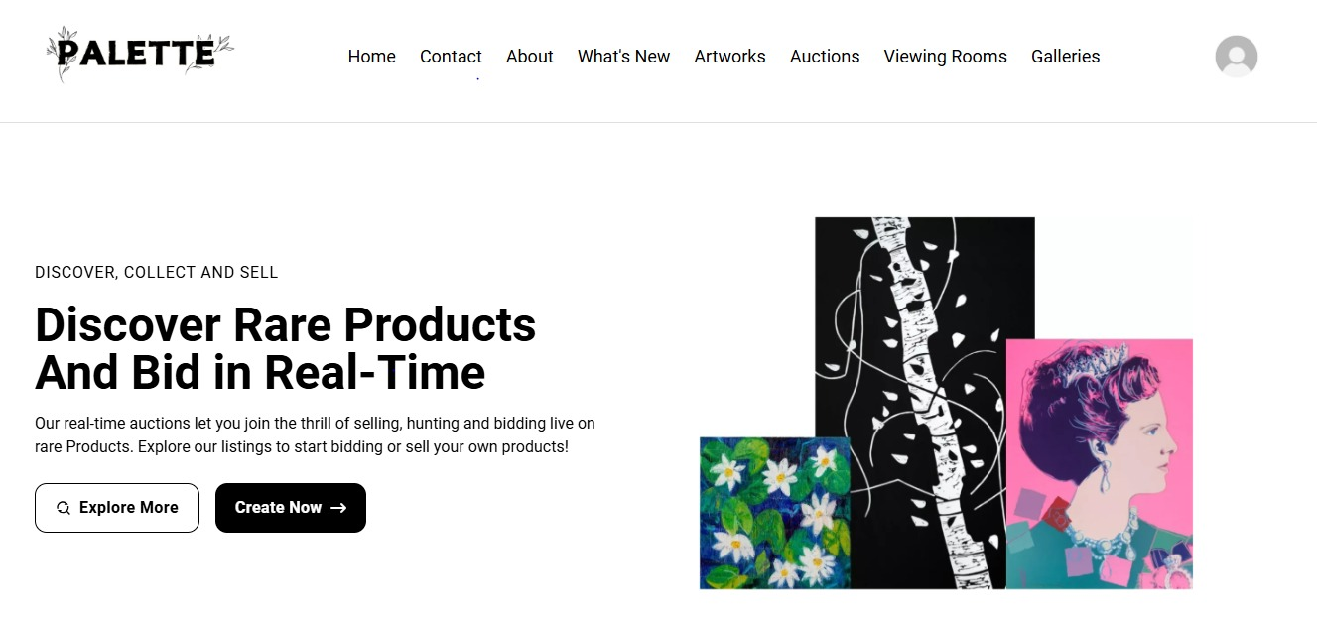**Homepage of User:**
* **Page of the auctions from user:**

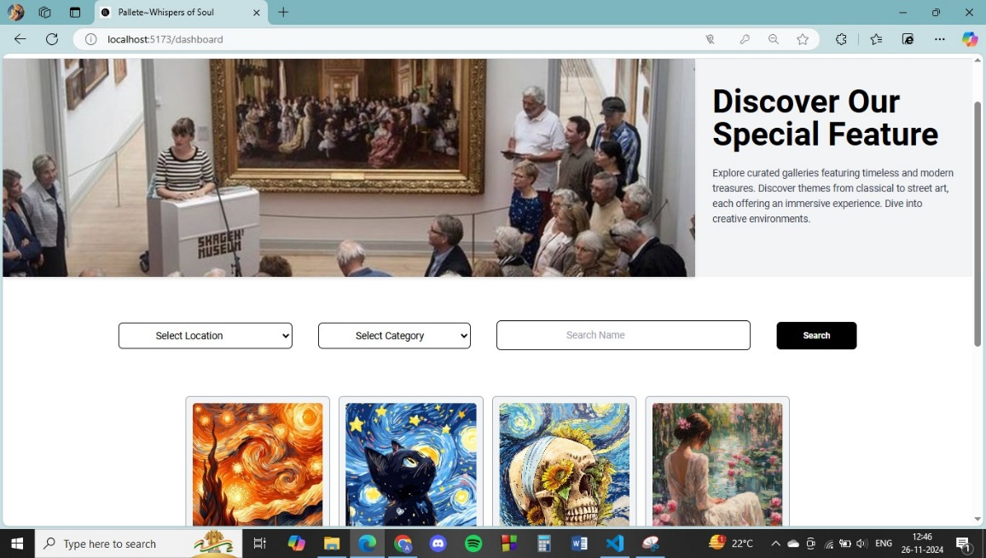

* 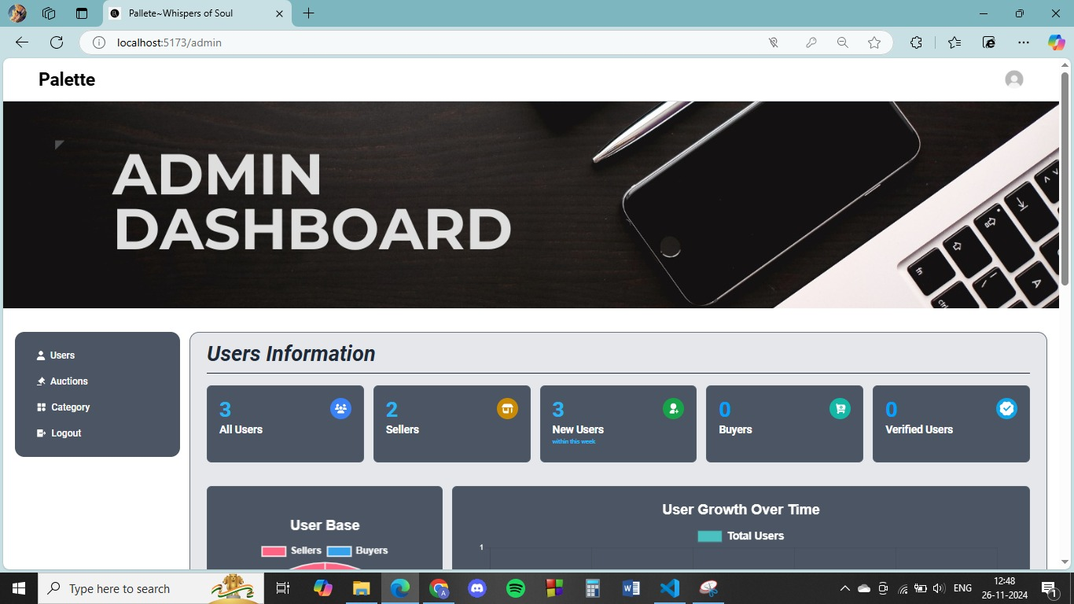**Page of admin dashboard:**
* **Page of User Profile:**

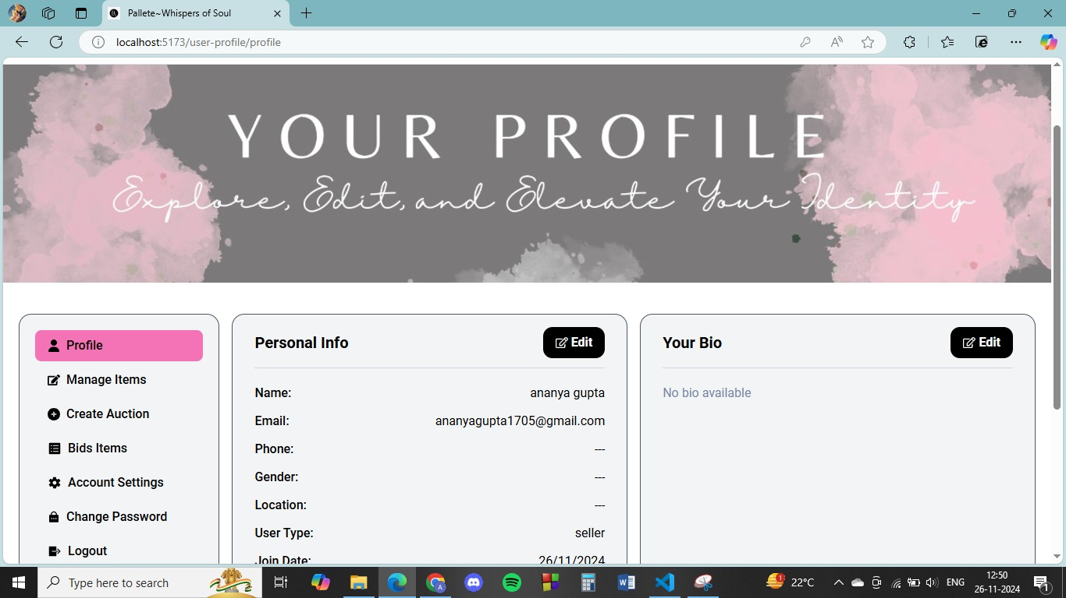

* 1. **METHODOLOGY**

**Requirement Gathering:**

* Conduct interviews with artists and art lovers to understand

their needs.

* Document all functional and non-functional requirements.

**Design and Planning:**

* Create wireframes and prototypes for major pages using Figma or Adobe XD.
* Define a timeline with milestones for development phases.

**Development:**

* Implement a mobile-first responsive design.
* Use RESTful APIs for database interaction and transaction handling.

**Testing:**

* Perform unit and integration tests to ensure all components function correctly.
* Conduct user testing for feedback on design and usability.

1. **RESULTS**

The platform will deliver a fully functional, visually appealing, and user-friendly art gallery website. It will provide an immersive experience for art lovers and empower artists with the tools to showcase and sell their creations.